Phase 4 Report — IDS Alerting with Suricata (pfSense)
Date: 2025-12-20

1. Objective
This phase enables Suricata on pfSense to provide IDS visibility. The lab generates controlled traffic from the LAN to the DMZ and confirms Suricata produces alerts that can be collected as evidence.

2. Topology
Suricata is enabled on the pfSense LAN interface. Kali generates traffic and Ubuntu hosts a web service in the DMZ.
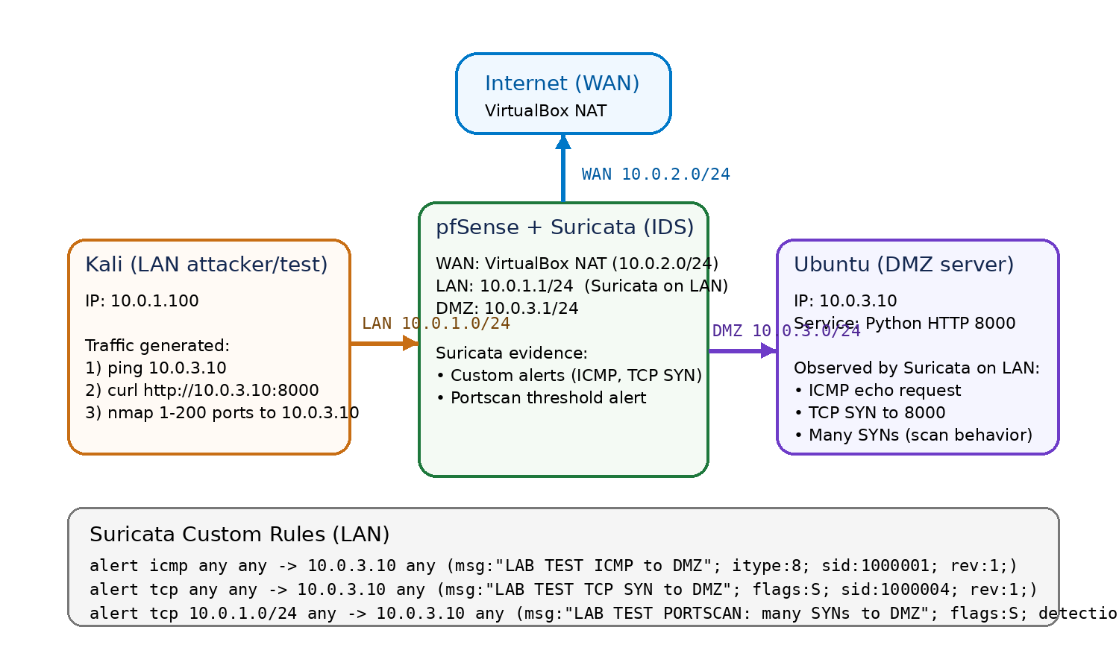
Figure 1. Phase 4 topology and Suricata custom test rules.

3. Suricata Configuration
Suricata was installed via pfSense Package Manager and enabled globally. A LAN interface instance was created and custom rules were added to guarantee alert generation.

4. Test Traffic Generated (Kali)
Three traffic patterns were generated to validate IDS alerting.
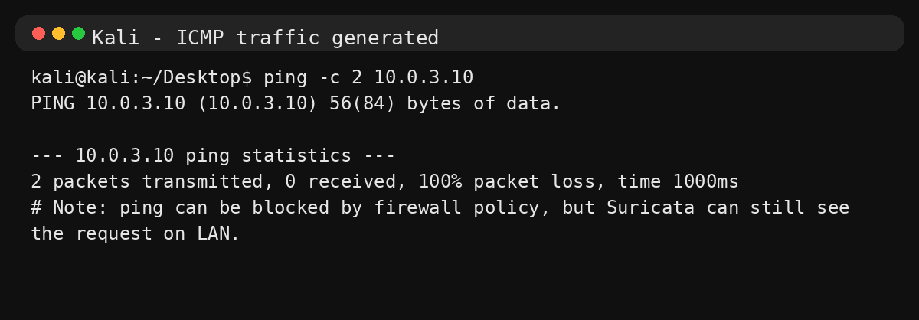
Figure 2. ICMP test traffic generated from Kali.
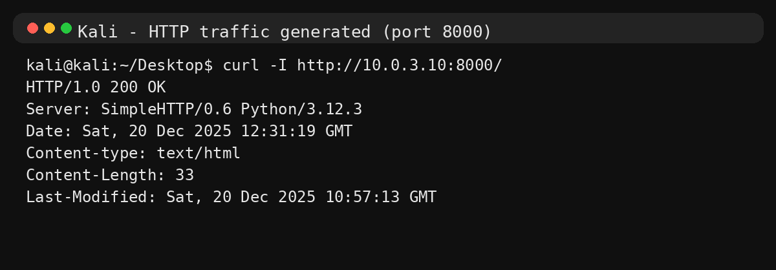
Figure 3. HTTP request to DMZ web server (port 8000).
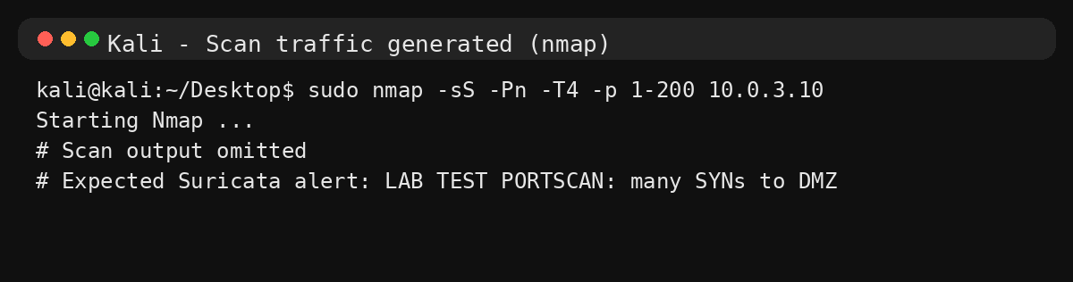
Figure 4. Nmap scan behavior generated from Kali.

5. Alerts Evidence (pfSense)
Alerts are viewed in pfSense under Services → Suricata → Alerts. Screenshots should capture the three custom alert messages and the associated source/destination IPs.
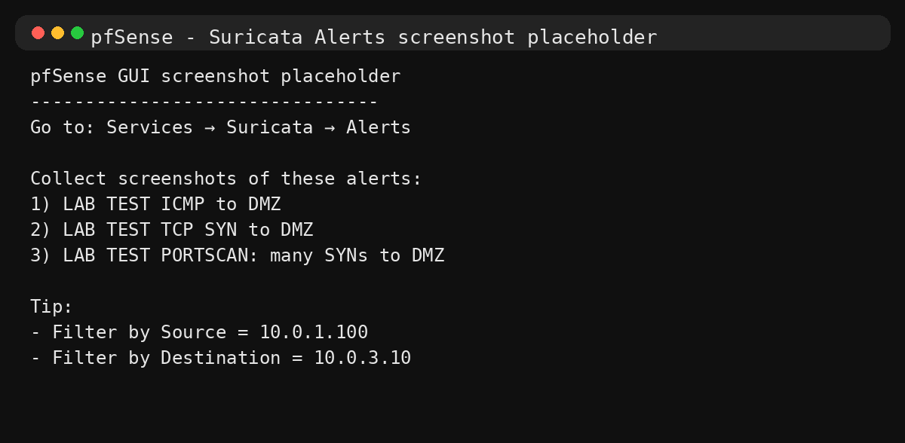
Figure 5. Placeholder — insert pfSense Suricata Alerts screenshots showing the three LAB TEST alerts.

6. Conclusion
Suricata successfully produced IDS alerts for ICMP traffic, TCP SYN visibility, and scan-like behavior. This provides the foundation for later phases: enabling more rule categories, tuning false positives, and optionally enabling IPS blocking.

